Pi1541 – Rotary Encoder Board Rev. 0

Module Description

The Rotary Encoder Board is intended to work with the Pi1541-HAT (Project 111) instead of the Pi1541-Switch Board (Project 112). Instead of the switches SW1 (Enter/Escape), SW2 (down) and SW3 (up) on the board mentioned above, a rotary encoder is used, which issues pulses (active low) to SW2 and SW3 depending on the direction in which it is turned. Pushing the axis of the rotary encoder will switch the SW1 signal.

The duration of the up or down pulses is determined by R/C combination and can be adapted to the requirements of the software. This way, no adaptation is requited of the Pi1541 software running on the Raspberry Pi to operate the rotary encoder.

The distances of the mounting holes, the LEDs and the switches remain the same like on the Pi1541-Switch board. The rotary encoder axis does not fit into the 8.6mm grid of the switches on the Pi1541-Switch board.

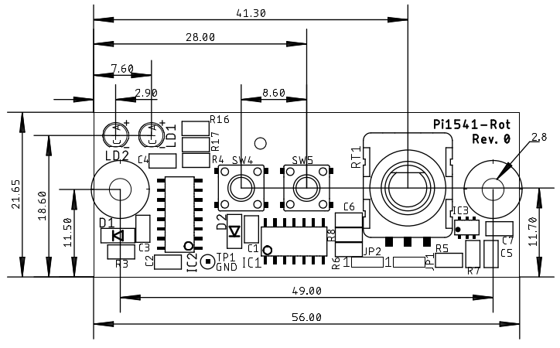

Figure 1: Measures of the Pi1541-Rot Board

# Switches Rotary encoder

The switches have functions according to the firmware and configuration, which can be found at this website: [https://cbm-pi1541.firebaseapp.com/](https://cbm-pi1541.firebaseapp.com/%20%20)

The default configuration is:

|  |  |
| --- | --- |
| Switch | Function |
| SW4 | Exit Folder |
| SW5 | Insert Disk |

|  |  |
| --- | --- |
| Rotary Enc. | Function |
| Push | Select/Reset |
| CCW | Move Up/Previous Disk |
| CW | Move Down/Next Disk |

# LEDs

|  |  |  |
| --- | --- | --- |
| LED | Color | Function |
| LD2 | Green | Power Indicator |
| LD1 | Red | Busy Indicator |

# Connector

X3: 8p Micro Match, female, THT (Tyco or alternative)

The ribbon cable can also be soldered in directly.

|  |  |
| --- | --- |
| Pin | Signal |
| 1 | /SW1 (push) |
| 2 | /SW2 (CCW) |
| 3 | /SW3 (CW) |
| 4 | /SW4 |
| 5 | /SW5 |
| 6 | LED_OUT (LD1) |
| 7 | +3V3 |
| 8 | GND |

# Placement of IC3

IC3 is a dual Schmitt trigger. The case is symmetric (SOT-23-6) and the pin 1 mark is not very visible.

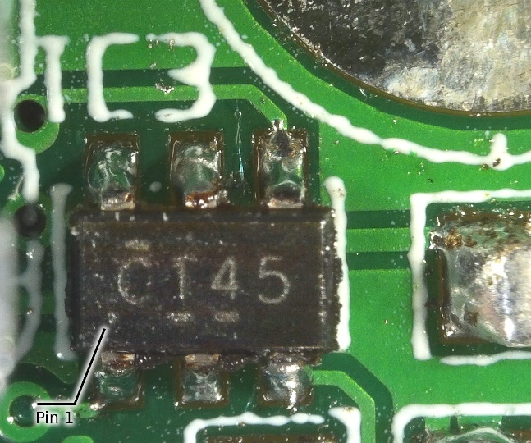

Figure 2: Placement of IC3

If the part marking is upright, pin 1 is at the left lower corner of the part as shown in Figure 2.